*For all problems, if you are asked to draw the circuit, you will need to draw the circuit too.

Question 1

In planet Z, there have been two new discoveries of Condition A and Condition B in plants. You have been tasked with creating a system which will detect the chances of development of Conditions A and B in plants. The conditions depend on the following factors:

Inputs (Factors) :
W: Temperature. (W=1 if the temperature is high, W=0 otherwise)
X: Oxygen Level (X=1 if oxygen level is normal, X=0 otherwise)
Y: Presence of UV Light (Y=1 if UV light is present, Y=0 otherwise)
Z :Humidity (Z= 1 if the humidity is high, Z=0 otherwise)

Outputs: A : Condition
B : Condition

- A plant will develop Condition A if presence of UV Light is accompanied by
i) a high temperature with normal oxygen level
or
ii) low humidity.

- If UV Light is absent then the plant will develop Condition A if there is
i) an abnormal level of oxygen
or
ii) there is high humidity with low temperature

- If the oxygen level is not normal or there is high humidity with low temperature then the plant will develop Condition B.

Devise a truth table for the system above which will detect the presence of the conditions based on the given factors. In your truth table, the input columns should be in the order WXYZ, where W is the MSB and Z is the LSB.

Draw K-map (s) based on the scenario above and derive simplified output (s).

Question 1 Answer

A=Σm(0,1,2,5,6,8,9,10,14,15)=W’Y’Z+X’Y’+YZ’+WXY= Y’(W’Z+X’) + Y(WX+Z’)
B=Σm(0,1,2,3,5,7,8,9,10,11)= X’ + W’Z

minterm | W | X | Y | Z | A | B
0 | 0 | 0 | 0 | 0 | 1 | 1
1 | 0 | 0 | 0 | 1 | 1 | 1
2 | 0 | 0 | 1 | 0 | 1 | 1
3 | 0 | 0 | 1 | 1 | 0 | 1
4 | 0 | 1 | 0 | 0 | 0 | 0
5 | 0 | 1 | 0 | 1 | 1 | 1
6 | 0 | 1 | 1 | 0 | 1 | 0
7 | 0 | 1 | 1 | 1 | 0 | 1
8 | 1 | 0 | 0 | 0 | 1 | 1
9 | 1 | 0 | 0 | 1 | 1 | 1
10 | 1 | 0 | 1 | 0 | 1 | 1
11 | 1 | 0 | 1 | 1 | 0 | 1
12 | 1 | 1 | 0 | 0 | 0 | 0
13 | 1 | 1 | 0 | 1 | 0 | 0
14 | 1 | 1 | 1 | 0 | 1 | 0
15 | 1 | 1 | 1 | 1 | 1 | 0

Question 2

A new bizarre coffee machine has two LED lights, RED and GREEN which light up based on certain inputs. You are asked to derive the internal circuit of the machine which enables the lights to glow. Depending on the inputs both the lights, any one of the lights or none of the lights may glow.

Inputs (Symptoms) :

W: Water Temperature. (W=1 if the water temperature is high, W=0 otherwise)
X: Amount of coffee beans (X=1 if sufficient amount of coffee beans is present, X=0 otherwise)
Y: Presence of Milk (Y=1 if milk is present, Y=0 otherwise)
Z :Sugar Level (Z= 1 if sugar level is normal, Z=0 otherwise)

Outputs: R : RED LED
G : GREEN LED

- The RED LED will light up if there is milk present and there is
i) an absence of coffee beans
or
ii) normal sugar level with low water temperature.

- If there is no milk then the RED LED will still glow up if there is

i) normal sugar level.
or
ii) a high water temperature with an adequate amount of coffee.

- The GREEN LED will light up if the sugar level is normal or when there is a high water temperature with sufficient amount of coffee beans present.

Devise a truth table for the system above which will detect the presence of the diseases based on the given symptoms. In your truth table, the input columns should be in the order WXYZ, where W is the MSB and Z is the LSB.

Question 2 Answer
R=Σm(1,2,3,5,7,9,10,11,12,13)=W’Z +X’Z+X’Y +WXY’
=Y(W’Z+X’) + Y’(WX+Z) (condition)
G=Σm(1,3,5,7,9,11,12,13,14,15)=Z + WX

minterm | W | X | Y | Z | R | G
0 | 0 | 0 | 0 | 0 | 0 | 0
1 | 0 | 0 | 0 | 1 | 1 | 1
2 | 0 | 0 | 1 | 0 | 1 | 0
3 | 0 | 0 | 1 | 1 | 1 | 1
4 | 0 | 1 | 0 | 0 | 0 | 0
5 | 0 | 1 | 0 | 1 | 1 | 1
6 | 0 | 1 | 1 | 0 | 0 | 0
7 | 0 | 1 | 1 | 1 | 1 | 1
8 | 1 | 0 | 0 | 0 | 0 | 0
9 | 1 | 0 | 0 | 1 | 1 | 1
10 | 1 | 0 | 1 | 0 | 1 | 0
11 | 1 | 0 | 1 | 1 | 1 | 1
12 | 1 | 1 | 0 | 0 | 1 | 1
13 | 1 | 1 | 0 | 1 | 1 | 1
14 | 1 | 1 | 1 | 0 | 0 | 1
15 | 1 | 1 | 1 | 1 | 0 | 1

Question 3

On planet Z, there have been two new outbreaks of Disease X and Disease Y. You have been tasked with creating a system which will detect the presence of Diseases X and Y. A person may have no disease or any one of the diseases or both. The presence of the diseases will depend on the following symptoms:

Inputs (Symptoms) :
A: Breathing Difficulties. (A=1 if you have breathing difficulties, A=0 otherwise)
B: Normal Body Temperature (B=1 if you have a normal body temperature, B=0 otherwise)
C: Fatigue (C=1 if you have fatigue, C=0 otherwise)
D :Loss of smell (D= 1 if the person has lost his ability of smell, D=0 otherwise)

Outputs: X : Disease X
Y : Disease Y

- You have Disease X if your fatigue is accompanied by
i) breathing difficulties with normal body temperature
or
ii) no loss of smell.

- If you don’t have fatigue then you will have Disease X if you have
i) an abnormal body temperature
or
ii) you have loss of smell with no breathing difficulties

- If you don’t have a normal body temperature or you have lost your sense of smell with no breathing difficulties then you have Disease Y.

Devise a truth table for the system above which will detect the presence of the diseases based on the given symptoms. In your truth table, the input columns should be in the order ABCD, where A is the MSB and D is the LSB.

Draw K-map (s) based on the scenario above and derive simplified output (s).

Question 3 Answer

X=Σm(0,1,2,5,6,8,9,10,14,15)=A’C’D+B’C’+CD’+ABC= C’(A’D+B’) + C(AB+D’)
Y=Σm(0,1,2,3,5,7,8,9,10,11)= B’ + A’D

minterm | A | B | C | D | X | Y
0 | 0 | 0 | 0 | 0 | 1 | 1
1 | 0 | 0 | 0 | 1 | 1 | 1
2 | 0 | 0 | 1 | 0 | 1 | 1
3 | 0 | 0 | 1 | 1 | 0 | 1
4 | 0 | 1 | 0 | 0 | 0 | 0
5 | 0 | 1 | 0 | 1 | 1 | 1
6 | 0 | 1 | 1 | 0 | 1 | 0
7 | 0 | 1 | 1 | 1 | 0 | 1
8 | 1 | 0 | 0 | 0 | 1 | 1
9 | 1 | 0 | 0 | 1 | 1 | 1
10 | 1 | 0 | 1 | 0 | 1 | 1
11 | 1 | 0 | 1 | 1 | 0 | 1
12 | 1 | 1 | 0 | 0 | 0 | 0
13 | 1 | 1 | 0 | 1 | 0 | 0
14 | 1 | 1 | 1 | 0 | 1 | 0
15 | 1 | 1 | 1 | 1 | 1 | 0

Question 4

On planet Z, there have been two new outbreaks of Disease X and Disease Y. You have been tasked with creating a system which will detect the presence of Diseases X and Y. A person may have no disease or any one of the diseases or both. The presence of the diseases will depend on the following symptoms:

Inputs (Symptoms) :
A: Normal Breathing. (A=1 if you have normal breathing, A=0 otherwise)
B: Abnormal Body Temperature (B=1 if you have an abnormal body temperature, B=0 otherwise)
C: Fatigue (C=1 if you have fatigue, C=0 otherwise)
D :Loss of smell (D= 1 if the person has lost his ability of smell, D=0 otherwise)

Outputs: X : Disease X
- You have Disease X if your fatigue is accompanied by
i) abnormal breathing with normal body temperature
or
ii) loss of smell.

- If you don’t have fatigue then you will have Disease X if you have
i) an abnormal body temperature
or
ii) you have loss of smell with normal breathing

- If you have fatigue or you have an abnormal body temperature with loss of sense of smell then you have Disease Y.

Devise a truth table for the system above which will detect the presence of the diseases based on the given symptoms. In your truth table, the input columns should be in the order ABCD, where A is the MSB and D is the LSB.

Draw K-map (s) based on the scenario above and derive simplified output (s).

Question 4 Answer

X=Σm(2,3,4,5,7,9,11,12,13,15)= AD + CD + BC’ + A’B’C
## C’(AD+B) + C(A’B’+D) =AC’D + BC’ + A’B’C +CD(condition)

Y= Σm(2,3,5,6,7,10,11,13,14,15)=C + BD

minterm | A | B | C | D | X | Y
0 | 0 | 0 | 0 | 0 | 0 | 0
1 | 0 | 0 | 0 | 1 | 0 | 0
2 | 0 | 0 | 1 | 0 | 1 | 1
3 | 0 | 0 | 1 | 1 | 1 | 1
4 | 0 | 1 | 0 | 0 | 1 | 0
5 | 0 | 1 | 0 | 1 | 1 | 1
6 | 0 | 1 | 1 | 0 | 0 | 1
7 | 0 | 1 | 1 | 1 | 1 | 1
8 | 1 | 0 | 0 | 0 | 0 | 0
9 | 1 | 0 | 0 | 1 | 1 | 0
10 | 1 | 0 | 1 | 0 | 0 | 1
11 | 1 | 0 | 1 | 1 | 1 | 1
12 | 1 | 1 | 0 | 0 | 1 | 0
13 | 1 | 1 | 0 | 1 | 1 | 1
14 | 1 | 1 | 1 | 0 | 0 | 1
15 | 1 | 1 | 1 | 1 | 1 | 1

Question 5

In planet Z, there have been two new discoveries of Condition A and Condition B in plants. You have been tasked with creating a system which will detect the chances of development of Conditions A and B in plants. The conditions depend on the following factors:

Inputs (Symptoms) :
W: Low Temperature. (W=1 if the temperature is Low, W=0 otherwise)
X: Oxygen Level (X=1 if oxygen level is abnormal, X=0 otherwise)
Y: Presence of UV Light (Y=1 if UV light is present, Y=0 otherwise)
Z :Humidity (Z= 1 if the humidity is high, Z=0 otherwise)

Outputs: A : Condition A
B : Condition B
- A plant will develop Condition A if presence of UV Light is accompanied by
i) high temperature with normal oxygen level
or
ii) low humidity.

- If UV Light is absent then the plant will develop Condition A if there is
i) an abnormal level of oxygen
or
ii) high humidity with low temperature

- If there is an abnormal level of oxygen or UV light is present in high humidity then the plant will develop Condition B.

Devise a truth table for the system above which will detect the presence of the conditions based on the given factors. In your truth table, the input columns should be in the order WXYZ, where W is the MSB and Z is the LSB.

Draw K-map (s) based on the scenario above and derive simplified output (s).

Question 5 Answer

A= Σm(2,3,4,5,6,9,10,12,13,14) =WY’Z+XY’+YZ’+W’X’Y= Y’(WZ+X) + Y(W’X’+Z’)
B= Σm(3,4,5,6,7,11,12,13,14,15) = X + YZ

minterm | W | X | Y | Z | A | B
0 | 0 | 0 | 0 | 0 | 0 | 0
1 | 0 | 0 | 0 | 1 | 0 | 0
2 | 0 | 0 | 1 | 0 | 1 | 0
3 | 0 | 0 | 1 | 1 | 1 | 1
4 | 0 | 1 | 0 | 0 | 1 | 1
5 | 0 | 1 | 0 | 1 | 1 | 1
6 | 0 | 1 | 1 | 0 | 1 | 1
7 | 0 | 1 | 1 | 1 | 0 | 1
8 | 1 | 0 | 0 | 0 | 0 | 0
9 | 1 | 0 | 0 | 1 | 1 | 0
10 | 1 | 0 | 1 | 0 | 1 | 0
11 | 1 | 0 | 1 | 1 | 0 | 1
12 | 1 | 1 | 0 | 0 | 1 | 1
13 | 1 | 1 | 0 | 1 | 1 | 1
14 | 1 | 1 | 1 | 0 | 1 | 1
15 | 1 | 1 | 1 | 1 | 0 | 1

Question No. 6 : Rock Scissors Game

Rock-paper-scissors is a game usually played between two people, in which each player simultaneously forms one of three shapes with an outstretched hand. These shapes are "rock" (a simple fist), "paper" (a flat hand), and "scissors" (a fist with the index and middle fingers together forming a V). The game has only three possible outcomes other than a tie: a player who decides to play rock will beat another player who has chosen scissors ("rock crushes scissors") but will lose to one who has played paper ("paper covers rock"); a play of paper will lose to a play of scissors ("scissors cut paper"). This time we have decided to slightly modify the game with only two options, Rock and Scissor.

Input (4 variables)
R1= 1 indicates Player 1 has chosen Rock.
S1 =0 indicates Player 1 has not chosen Scissor.
R2 =0 indicates Player 2 has not chosen Rock.
S2 = 1 indicates Player 2 has chosen Scissor.

Output (3 variables)

P1 = 1 indicates Player 1 is winner
P2 = 1 indicates Player 2 is winner
D = 1 indicates there is a tie
We have to consider the following points when designing the game:
i) If player 1 or player 2 has not chosen anything, there will be no winner nor tie. ii) A player cannot choose rock and scissor both at a time. This state can be considered as DON’T CARE.
a) Using the above specification, prepare a truth table for the game.
b) Using 4 variable Karnaugh-Map method, derive SOP expressions for all of the three possible results.

Solution:

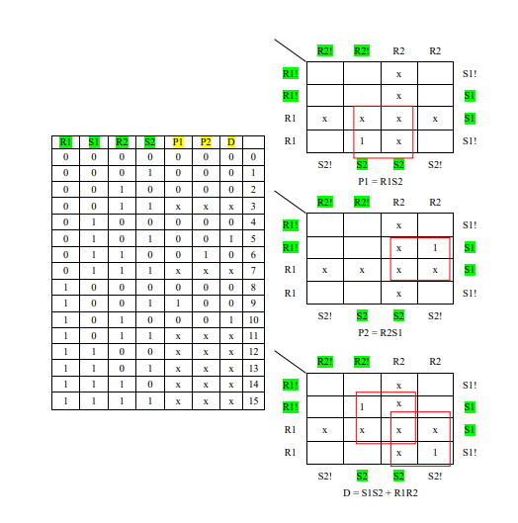

Question 7

You are tasked with designing a system that will take customer preference as input and suggest between two types of transportation based on the following criteria.
Inputs
I. D = 1 means traveling distance is long, 0 means traveling distance is short
II. B = 1 means budget is high, 0 means budget is low
III. W = 1 means weather is dry and 0 means weather is rainy
IV. T = 1 means it is night-time, 0 means it is day-time
Outputs
Ride-Sharing Transport, R
Public Transport, P
The outputs will depend on the following conditions:
- Public transport will be selected if it is day and either budget is low or weather is dry.
- Public transport can also be selected at night if the weather is dry and the customer is travelling for a short distance.
- Weather must be rainy for selecting Ride-Sharing transport.
- Ride-Sharing transport will be selected with either long distance or more budget.
- Machine can suggest both Ride-Sharing transport and Public transport at the same time.

Devise a truth table for the system above which will suggest transport medium to the customer based on the given preferences. In your truth table, the input columns should be in the order DBWT, where D is the MSB and T is the LSB.

Use K-map(s) based on the scenario above and derive simplified output(s).

Question 7 Solution

Truth Table | K-Map  Public Transport  P = B’T’ + D’W + WT’  Ride-Sharing Transport  R = DW’ + BW’
  D | B | W | T | R | P
  0 | 0 | 0 | 0 | 0 | 1
  0 | 0 | 0 | 1 | 0 | 0
  0 | 0 | 1 | 0 | 0 | 1
  0 | 0 | 1 | 1 | 0 | 1
  0 | 1 | 0 | 0 | 1 | 0
  0 | 1 | 0 | 1 | 1 | 0
  0 | 1 | 1 | 0 | 0 | 1
  0 | 1 | 1 | 1 | 0 | 1
  1 | 0 | 0 | 0 | 1 | 1
  1 | 0 | 0 | 1 | 1 | 0
  1 | 0 | 1 | 0 | 0 | 1
  1 | 0 | 1 | 1 | 0 | 0
  1 | 1 | 0 | 0 | 1 | 0
  1 | 1 | 0 | 1 | 1 | 0
  1 | 1 | 1 | 0 | 0 | 1
  1 | 1 | 1 | 1 | 0 | 0
  DB/WT | 00 | 01 | 11 | 10
  00 | 1 |  | 1 | 1
  01 |  |  | 1 | 1
  11 |  |  |  | 1
  10 | 1 |  |  | 1
  DB/WT | 00 | 01 | 11 | 10
  00
  01 | 1 | 1
  11 | 1 | 1
  10 | 1 | 1

Question 8

You need to create an automated system that will suggest your eligibility for either Domestic trip or International trip based on the following factors.
Input (4 variables)
T = 1 indicates you are planning for a short trip, 0 if your plan is for a long trip
V = 1 indicates that you require a visa for the tour, 0 if visa is not required
B = 0 indicates that you have a high budget, 1 if the budget is low
P = 0 indicates that you will travel by plane, 1 if you will travel by train
[Note: You need to maintain the input order as TVBP with T as the MSB and P as the LSB]
Output (2 variables)
D = 1 indicates that you are eligible for domestic trip, 0 otherwise
I = 1 indicates that you are eligible for international trip, 0 otherwise
You have to consider the all following conditions:
- Visa is mandatory for an International trip.
- The International trip will ONLY work with plane transportation and the Domestic trip will work with both plane and train.
- International trip requires either a high budget or a long trip.
- Domestic trip can be planned with a low budget only if the trip is short.
- Domestic trip can also be planned with a high budget if you plan on traveling by a plane
- Your system cannot suggest both Domestic trip and International trip at the same time. In these cases, International trip will receive priority over Domestic trip

Draw the truth table for the scenario above.

Using the Karnaugh-Map Method, find the required simplified SOP expression for the given outputs.

Question 8 Solution

 | 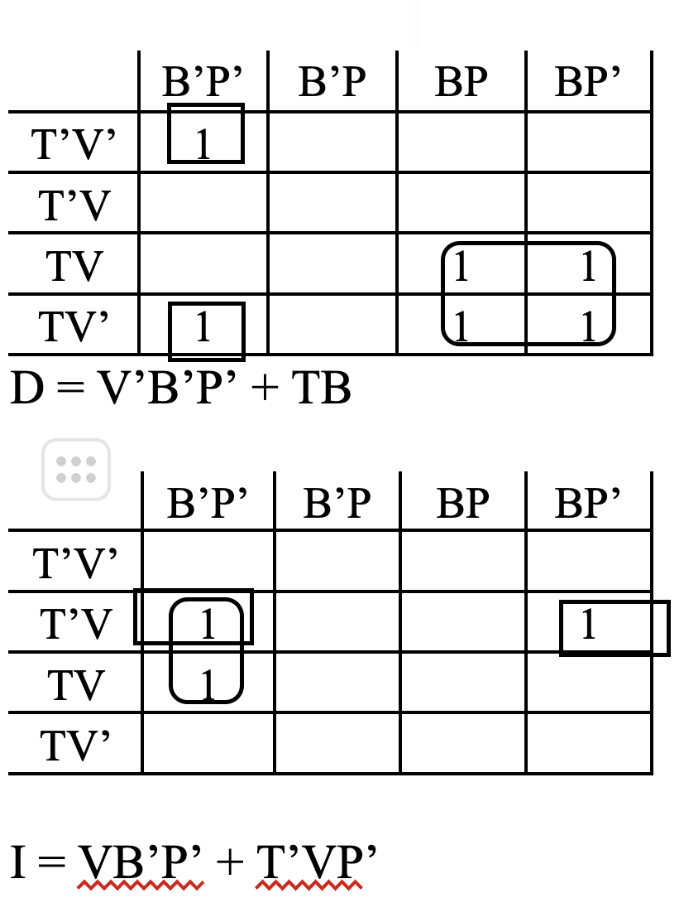
  T | V | B | P | D | I
  0 | 0 | 0 | 0 | 1 | 0
  0 | 0 | 0 | 1 | 0 | 0
  0 | 0 | 1 | 0 | 0 | 0
  0 | 0 | 1 | 1 | 0 | 0
  0 | 1 | 0 | 0 | 0 | 1
  0 | 1 | 0 | 1 | 0 | 0
  0 | 1 | 1 | 0 | 0 | 1
  0 | 1 | 1 | 1 | 0 | 0
  1 | 0 | 0 | 0 | 1 | 0
  1 | 0 | 0 | 1 | 0 | 0
  1 | 0 | 1 | 0 | 1 | 0
  1 | 0 | 1 | 1 | 1 | 0
  1 | 1 | 0 | 0 | 0 | 1
  1 | 1 | 0 | 1 | 0 | 0
  1 | 1 | 1 | 0 | 1 | 0
  1 | 1 | 1 | 1 | 1 | 0

Question 9

Suppose you want to make a 4-bit calculator. This isn’t your regular calculator and now it’s only in the testing phase. It does binary calculations and can only show two types of output for now. You have inputs (W, X, Y, Z) and Output (A,B).

Conditions:
- Summation result of W+X+Y+Z will be stored in A. In case of carry bit, you will ignore that and only the sum will be stored in A. However if there exists more than two 1s in the input bits then it will be considered as don’t care in the output.
In case you don’t know what sum and carry bit means, please check the following example:
When adding two binary digits (bits), the sum can result in either 0 or 1:
0 + 0 = 0 (Result is 0, so Sum 0 and Carry 0)
0 + 1 = 1 (Result is 1, so Sum 1 and Carry 0)
1 + 0 = 1 (Result is 1, so Sum 1 and Carry 0)
1 + 1 = 10 (Result is 10, so Sum 0 and Carry 1)

- The result of (( W ✕ Z ) + ( X ✕ Y )) will be stored in B. However, if X, Y or W, Z has alternate bits then that will be considered as don’t care. For example, X=1 , Y=0 or vice versa. W=1, Z=0 or vice versa.
Note: + means addition and ✕ means multiplication

Create a truth table for the above mentioned calculator system. For output, use the variables A, B & use don't care values where necessary. For inputs, use W,X,Y,Z in such an order where W is MSB and Z is LSB.

Use Karnaugh Map to find out the simplified expressions for each of the outputs.

Question 9 Solution
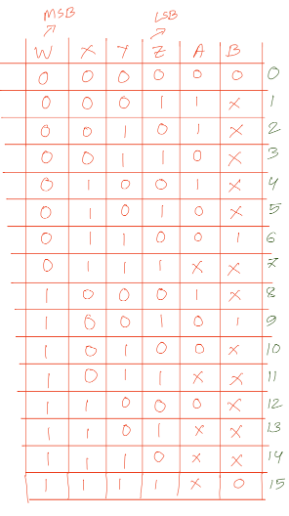
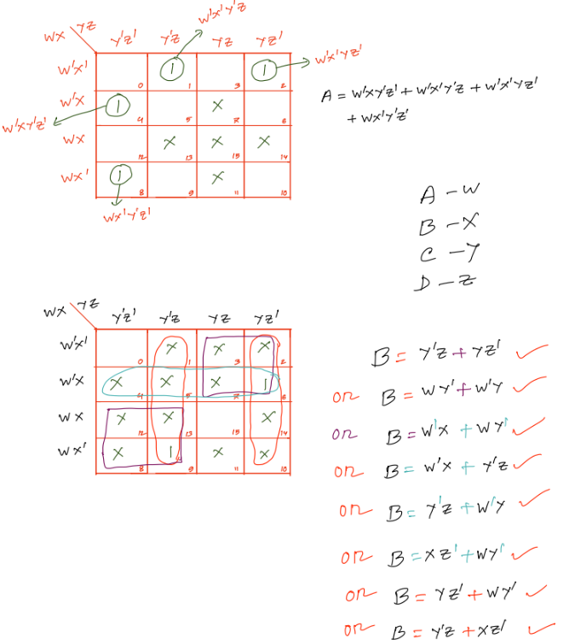

Question 10

At the distant corner of the galaxy, a mysterious planet named Nebula has been discovered where the civilization is rumored to possess similar intellectual properties as humans. They tend to use a 10-base number system. However, the alphanumeric characters are a bit different from the ones used by humans. Moreover, they use a 4 segment display system to represent all the digits.
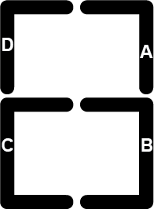

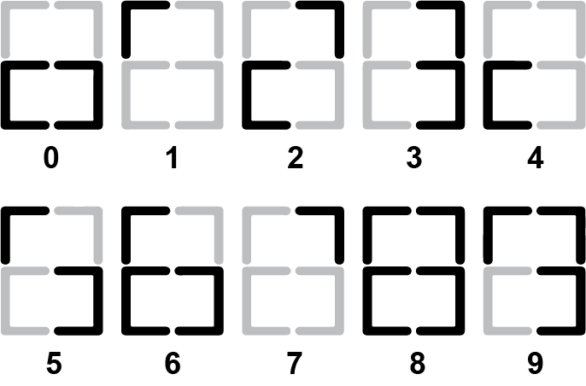
To display these above-mentioned 10 numbers, use the necessary number of input variables and create a truth table for the 4 segment display system. For output, use the variables A, B, C, D as given in the picture & use don't care values where necessary.

Use Karnaugh Map method to find out the simplified expressions for each of the outputs.

